**Principles of Microeconomics**

**Group Project**

**Semester 1, 2020**

## Name: 戴轶伦 范雅威 林博文 刘仕祎 王佳琦

**Class: 商学院2020级本科2班（经济学原理Ⅰ—工商管理2班）**

**Date of Submission: 2021/1/2**

1. **Introduction**

In this report, we will analyze 5 phenomena mentioned in recent news reports.

For article#1, we choose this news report because here we can see how the policy affect market. It’s important for us to predict the changes in a market according to new policies. The concept discussed would be the law of supply and demand and market equilibrium

For article#2, we select this theme because with the background of globalization, we are buying more imported goods than ever and knowing how tariff affect the market is of vital importance. The concept welfare economics in tariff will be discussed. The principle that trades make everyone better off can be applied to this report.

For article#3, we select this theme because tax is so common yet invisible that we are likely to ignore it every time we pay. It would be useful to know how tax affect the government revenue as well as the surplus of consumers and producers. The concept discussed would be welfare economics in taxation.

For article#4, the phenomenon included is closely related to our daily life. we focus on price discrimination and try to explain VIP costs more than others. We are discussing the concept price discrimination.

For article#5, we try to analyze the market of pork. Pork is an important raw material in Chines cuisine. Thus, the price of pork has a great influence on people’s daily life. The concept included in this report is perfectly competitive market.

## 2.Discussion

**Newspaper Article #1**

### Article Title: New equilibrium in the market of second-hand cars in Shanghai

Article URL: <http://industry.caijing.com.cn/20201112/4713943.shtml>

Microeconomics concept discussed: the law of supply and demand; equilibrium

Recently, there is a fall in the market price of second-hand petrol cars and a rise in the market price of second-hand new energy vehicles in Shanghai. This report aims to analyze this phenomenon using the knowledge of market equilibrium.

Equilibrium is a situation where market price has reached the level at which quantity supplied equals quantity demanded. To analyze market equilibrium, we usually have three steps. First, we decide whether the event shifts the supply curve and the demand curve. Second, we decide whether the curve shifts to right or left. Third, we use the supply-demand diagram to compare the initial and the new equilibrium.

First of all, we roughly assume the market of second-hand cars in Shanghai is a perfectly competitive market, as there are many buyers and sellers, goods are exactly the same, and buyers and sellers have little influence over the market price.

Then, we analyze the two factors effecting the market price——supply and demand. In short, as for the second-hand petrol cars, the supply has increased and as for the second-hand new energy vehicles, the demand has increased.

To see why this happened, we can find clues in the recently released policy in Shanghai.

According to the new policy, from 7:00 to 20:00 a.m. on November 2, some main elevated roads, bridges and tunnel roads in Shanghai will be prohibited from passing passenger cars with vehicle license plates of other provinces and cities, passenger cars with temporary driving license plates, taxi passenger cars without passengers and passenger cars driven by drivers during the internship period (except Saturdays, Sundays and holidays for all citizens). In addition, after the May Day holiday in 2021, the inner ring road will also be open to licensed vehicles with limited period. Thus, those who own vehicles with license plates of other provinces and cities are urging to sell their cars because of the inconvenience they will have to face. Meanwhile, because the new energy vehicles are not included in the new policy, many people are planning to buy these cars with green license plates. Thus, the factors mentioned above would cause both the supply curve of second-hand petrol cars and the demand curve of second-hand new energy vehicles to shift to the right.

Finally, let’s see how the equilibrium price and quantity change. As for the market of second-hand petrol cars, the point where supply and demand curve intersect is lower and more to the right. This reflects a fall in the equilibrium price and a rise in the equilibrium quantity. As for the market of second-hand new energy vehicles, the point where supply and demand curve intersect is higher and more to the right. This reflects a rise in both the equilibrium price and quantity.

Diagram for Second-hand petrol cars:

Diagram for second-hand new energy vehicles:

Because the new equilibrium has formed, Chengming told the reporter of National Business Daily that the quantity of second-petrol cars sold each day has reached ten or more and the price is cheaper for 10,000yuan compared with the past.

## Newspaper Article #2

### Article Title: China's reduced, canceled import tariffs for 2021

Article URL: <https://global.chinadaily.com.cn/a/202012/30/WS5febb041a31024ad0ba9f662.html>

Microeconomics concept discussed: The application of welfare economics to tariff

China will reduce or cancel tariffs on certain imported goods and materials starting in 2021 under the country's new "dual-circulation" development paradigm. The new interim tariff rates on imports, which will be lower than Most Favored Nation tariff rates, will apply to 883 kinds of goods including foods, medicines and information technology products.

In this passage, I will analyze how tariffs affect the welfare economics.

There are three different levels of tariff adjustments.

First, lower the tariffs on some materials for medical equipment, new infrastructure construction and high-tech industries; anti-cancer drugs; wood and paper products; etc.

Second, cancel the tariffs on solid waste, some special formula foods for sick children and so on.

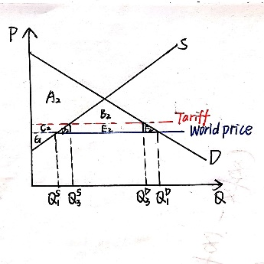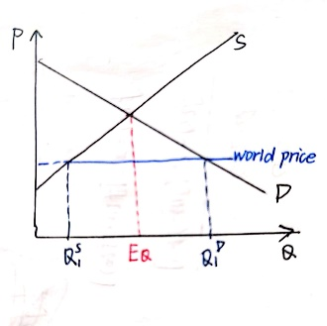

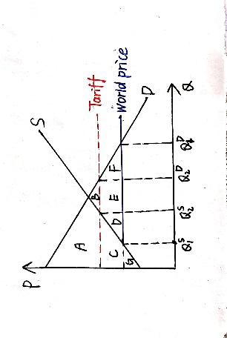

Lowering or canceling the tariffs increases the consumer surplus but decrease the domestic producer surplus and revenues from tariffs. On the whole, it increases total surplus and decreases deadweight loss.

From the consumers’ point of view, because the world price is lower than equilibrium price, they can buy products at lower prices. Imported products or services enrich the diversity of the market, which satisfy consumers’ various needs and enhance the quality of consumers’ lives.

From the producers’ standpoint, they are influenced differently. For one thing, imported products or services increase the competition and lower the market price, resulting in their decreasing surplus. However, it in turn motivates domestic suppliers to optimize products and services.

For another, the main reduction is in tariffs on some raw materials that lower the production cost of Chinese manufacturers and encourage production. The producer can become more competitive through lowering the total cost. And when the low price causes high quantity demanded and shortage, the expanding market is promising and profitable.

As for the government, its revenue decreases but the domestic economy boosts dramatically.

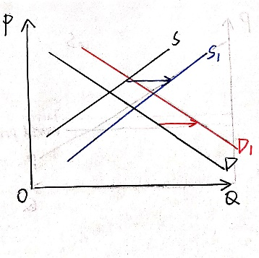

S → S1 the increase of imports and domestic production

D → D1 ever-increasing domestic demand

boost the domestic market and maintain the price in some degree

Third, cancel temporary tariff rates on the import of solid wastes and resume MFN rates that are higher than the temporary tariff rates.



lower tariff higher tariff

This adjustment can prevent solid waste from polluting the environment, protect public health and promote sustainable economic and social development.

In a word, it vividly exemplifies one of ten principles of economics that trades make everyone better off. Tariff adjustment is conducive to better attracting global resources and factors, better satisfying domestic demand, and improving China's industrial development level and competitiveness. The further opening up of China's market also provides more opportunities for countries around the world, and helps speed up the construction of a network of high-standard free trade areas.

## Newspaper Article #3

### Article Title: Sugar Tax are Changing Soft Drink Industry

Article URL: https://www.healthline.com/health-news/could-uk-sugar-tax-work-in-the-us

Microeconomics concept discussed: Welfare economics, Taxation

In 2018, multiple localities in the United States have implemented taxes on sugar-sweetened drinks, in order to call on healthier consuming habits. The so-called “sugar tax” influenced the whole soft drink industry, urging companies like Coca and Pepsi to produce more diet soda. Meanwhile, consumers obviously purchased fewer sugar-sweetened drinks after the tax were put on producers/dealers.

Take the tax in Philadelphia as an example. Sugar tax in Philadelphia is charged on dealers[1], with tax rate of $0.015 per ounce of sweetened beverage.

Suppose the original equilibrium price of sweetened beverage was $0.1 per ounce, and both supply and demand were unit elastic. When the tax policy was employed, the tax burden would be distributed to both consumers and dealers. The calculation results and the chart are listed below:

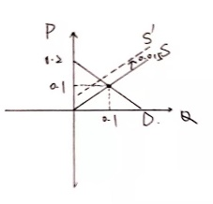Demand curve: p=-q+0.2

Supply curve: p=q

Supply curve shifted after charging tax: p=q+0.015

New equilibrium price: 0.1075

Price sellers receive: 0.925

Tax burden is distributed on consumers and dealers. As a result, the demand and supply of sweetened beverage would decline. The reasons of the change are hidden in tools of welfare economics. Let us consider deadweight loss and changes in consumer surplus and producer surplus before and after the policy of sugar tax employed. The calculation results and charts are listed below.

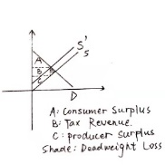 Tax revenue: 0.0013875

Deadweight loss: 0.00005625

Consumer surplus: 0.004278125

Producer surplus: 0.004278125

The results above suggest that sugar tax actually damages the efficiency of sweetened soda market. So, producers/dealers will reduce the quantities of sweetened soda supplied, and consumers’ purchasing habits will be changed—— consumers will prefer sugar-free drinks and sales of juice or water （ substitute ）will increase.

In real life events, the elasticity of demand for sweetened soda is different for different groups of people, so the deadweight loss/consumer surplus will be different in real life.

Another possible interesting result is that, as sugar tax is not national tax in the US, but is charged differently in each state, consumers who are strongly fond of sweetened soda can go to another state to buy certain drinks with lower tax rate or even without extra sugar tax. Different tax rates may cause different sales quantities of sweet drinks. It seems that disunity standard of tax rates would not force residents to form healthy lifestyle thoroughly as the government once thought. However, costs of the drinks are much lower than costs of travelling between states, so consumers probably would not purchase in other states to avoid higher sugar taxes. So, it is different between purchasing luxury goods over states(like “代购” in China) and purchasing daily goods over states.

In conclusion, sugar tax employed in the US is useful to adjust consuming habits and urge people to pursue healthy lives.

**Newspaper Article #4**

### Article Title: I Was Played for a Sucker by Meituan

Article URL: https://weibo.com/ttarticle/p/show?id=2309404582309104845257#_0

Microeconomics concept discussed: Price Discrimination

Last month, an article titled ‘I was played for a sucker by Meituan’ went on trend. The author, who was charged higher price after he got the VIP on Meituan, presented the fact that Meituan actually charges different prices to different customers. This is a typical case of price discrimination.

Price discrimination is the practice of selling the same good at different prices to different customers which results from monopoly. Though it can maximum sellers’ profits, it can also damage consumers’ profits and lead to inequality. And in some nations, it is an illegal action. In Meituan’s cases, the writer named Piaoyishenfu, bought a VIP in Meituan. He soon found out though he could have more discount, the deliver price actually went higher. In other words, the money he paid for VIP did not do any good to him. So he questioned Meituan made immoral profits by designing different prices towards different customers. This case is extremely special because it is like a variation in two-part tariff. The VIPs are supposed to obtain more benefits than the common customers in two-part tariff strategy. But Meituan actually turns the winner upside down----the VIPs, who pay more yet get less. The membership fees they pay for the platform do not do any good to them. It seems like the common customers win more benefits in this situation.

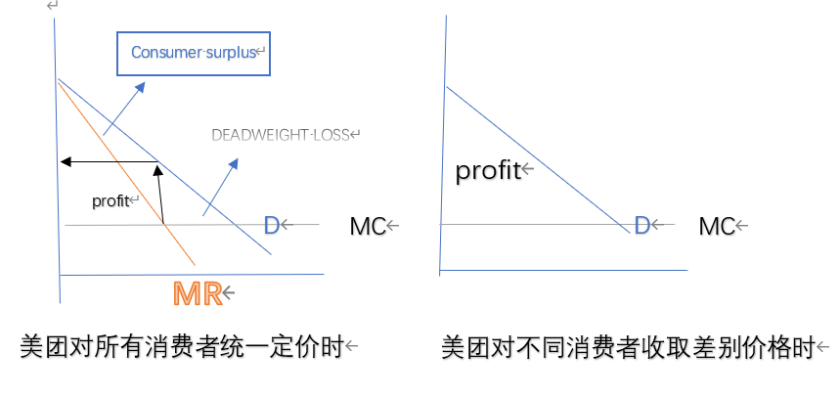This action do bring more profits to the company. As the graph shows, by charging different customers for different prices, the deadweight loss can be minimum. Thus, company can get more economic welfare.

Though the company can make more profits in the short run, it can eventually be harmful for company once these invisible actions are found out. Meituan is a great market power in China. Yet it is a part of oligopoly rather than a monopolist, which means consumers can choose other companies for the same kind of service. So as soon as this article appeared, Meituan’s fame has been damaged and a lot of consumers showed their unwilling to use Meituan delivery on the Internet. It may result in many customers to choose the service provided by its competitors and it can lead to the decline in the market shares for Meituan. Eventually, the profits of Meituan will tend to decline rather than increasing. And this may affect the company for many years since its credibility has been damaged.

In order to deal with these problems, the whole society needs to take actions from now on. For the government, we need more clear anti-trust law in China. Since the history of market economy is quite short in our nation, the law has no thoroughly clear measures towards the companies who use their power to create a monopoly or fix prices unreasonable. Recently, more signals towards anti-trust law in China has been released from China officials. Taobao and Tencent have faced grilling from the officials for their monopolistic conduct. And the companies need a series of moral mind identity to make sure they function legally and can create fortune for customers in ire aspects. Companies need to bear in mind that the nature of business is to create value for customers rather than make their own wealth. Finally, as customers ourselves, we need to know more about our rights in the transaction and fight with the sellers’ unreasonable or illegal actions.

## Newspaper Article #5

### Article Title:Thousand Real Estate Enterprises Are Raising Pigs for Bonus

Article URL: https://mp.weixin.qq.com/s/5aDmzS8yP8xETDTMkIOGjQ

Microeconomics concept discussed: Perfectly Competitive Market

Due to various factors, the price of pork has continued to rise in recent period. As a result, a great number of firms are joining the aquaculture industry, including many real estate and Internet companies. This report aims to explain this phenomenon by using the perfect competition market model.

In the pork market, there are a large number of buyers and sellers. The goods(pork) provided by every seller are basically the same, and every buyer or seller can be regarded as a price taker. In addition, the entry and exit of pork market are relatively free as there are almost no obstacles. Therefore, pork market can be regarded as perfectly competitive market.

From the middle of November 2020, the price of pork has changed from the previous decline to an increase. This is influenced by many factors. From the supply side, after the African swine plague, the pork supply capacity of producers declined. From the perspective of consumers, with China's COVID-19 under control, consumer confidence is gradually restored and the demand for pork in the catering industry is increasing. What’s more, Southerners' custom of making bacon in winter also led to a rise in pork prices.

Pork prices are rising rapidly, while the average total cost and the marginal cost of producers has little change. This leads to economic profits for producers in the short run.

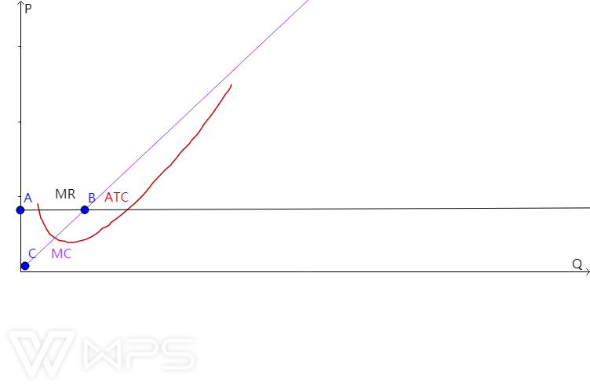

Motivated by economic profits, many companies will enter the pork market, as described in the news. With more and more producers in the market, the supply curve will shift and the price will drop until it is lower than the lowest average cost.

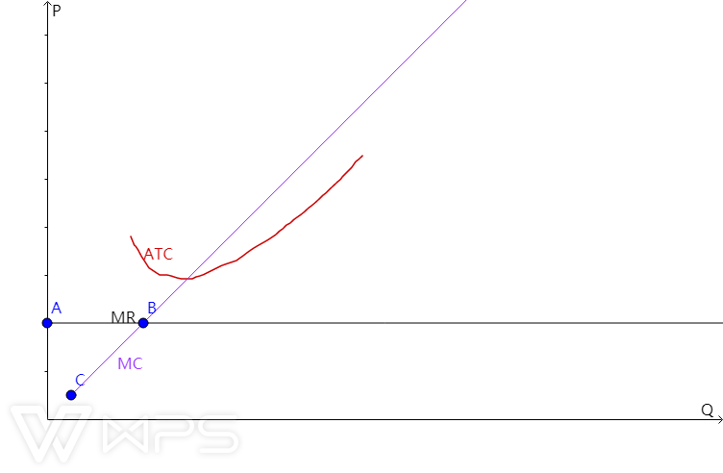

As a result, producers will get negative economic profits. This will cause some producers to exit the pork market, which will increase the price of pork. It can be predicted that after a long period of time, the price of pork will stabilize, which is basically equal to the minimum average cost. At this point, the market is in equilibrium.The economic profit of producers tends to zero.At this point, the pork market is efficient.

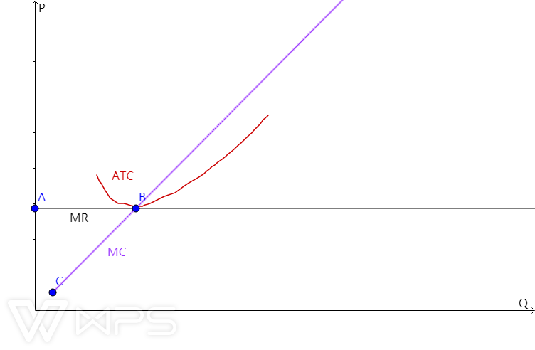

In fact, because the factors affecting pork price are too complex, the time for pork market to stay in equilibrium is very short, and it is often in fluctuation. In China, the process of adjusting pork market from disequilibrium to equilibrium is called "pork cycle". Although in the equilibrium state of the market, resources are optimally allocated, but in the process of reaching equilibrium, a lot of resources are often wasted. When the price is too high, consumers will suffer; when the price is too low, farmers will suffer.This reflects the limitations of the "invisible hand" .For social welfare reasons, the Chinese government often uses public power, such as issuing reserved pork and limiting the price, to maintain market stability.

In addition, China's pork market is developing towards oligarchy as several giant companies in the breeding industry grasp more and more market power. But thanks to the government's control, we don't need to worry about whether we can enjoy braised pork yet.

## Conclusion

In all the five reports above, phenomena closely related to residents’ lives are selected, from daily necessaries, drinks to take-out services and importing and exporting goods. We can see how decisions made in firms and how policies like taxation deeply influence consumers’ habits and living standards, which reveals the importance of government controls and appropriate policies that protect inhabitants’ basic living conditions.Market are usually a good way to organize economic activities, while governments can sometimes improve market outcomes.

## References:

Tax rate of sugar in Philadelphia, government website: https://www.phila.gov/services/payments-assistance-taxes/business-taxes/philadelphia-beverage-tax/#:~:text=1.5%20cents%20per%20ounce%20of%20sweetened%20beverage%20distributed.,will%20be%20added%20to%20the%20amount%20you%20owe.

---- END OF REPORT ----

1. Such as delis, restaurants and grocery stores, as well as hospitals, schools, nonprofit groups, and others